

Practices for Secure Software Report

Table of Contents
Document Revision History 3
Client 3
Instructions 3
Developer 4
1. Algorithm Cipher 4
2. Certificate Generation 4
3. Deploy Cipher 4
4. Secure Communications 4
5. Secondary Testing 4
6. Functional Testing 4
7. Summary 4
8. Industry Standard Best Practices 4

Document Revision History

Version | Date | Author | Comments
1.0 | 10/10/2026 | Whitney Dempsey

Client



Developer
Whitney Dempsey

Algorithm Cipher

I recommend the Advanced Encryption Standard (AES) with a 256-bit key to protect Artemis Financial’s sensitive customer information. AES is a symmetric encryption algorithm that processes data in 128-bit blocks and supports key sizes of 128, 192, and 256 bits. AES-256 provides a large key space that makes exhaustive key guessing computationally impractical when keys are generated and managed securely. Protecting the key is essential because symmetric encryption uses the same secret key to encrypt and decrypt information (Manico & Detlefsen, 2014; Oracle, n.d.).

For the application’s checksum requirement, I implemented SHA-256 using Java’s MessageDigest class. SHA-256 is a hashing algorithm rather than an encryption cipher. It produces a 256-bit digest, displayed as 64 hexadecimal characters, without using an encryption key (Oracle, n.d.). The application hashes a unique string containing my name, and I independently verified the result using PowerShell. Matching checksums support data integrity verification, but a checksum alone does not establish the sender’s identity. AES encryption, SHA-256 hashing, and digital signatures serve different security purposes.
Asymmetric cryptography uses a public and private key pair instead of a shared secret key. The private key must remain confidential, while the public key can be distributed for operations such as signature verification. This project uses a certificate containing a 2048-bit RSA public key to support HTTPS. Secure random numbers are important for generating unpredictable cryptographic keys. The textbook discusses Java’s SecureRandom class as a source of randomness for security operations. However, the checksum itself does not require randomness: identical input must produce an identical hash so that results can be compared (Manico & Detlefsen, 2014).

Encryption has developed from older approaches such as DES and Triple DES to algorithms such as AES. Oracle’s documentation identifies AES as the Rijndael algorithm standardized by NIST in FIPS 197 and distinguishes it from those earlier algorithms (Oracle, n.d.). Secure applications must consider key sizes, key protection, and maintained implementations when selecting encryption technologies. For Artemis Financial, AES-256 is my encryption recommendation; the demonstrated application changes implement SHA-256 checksum generation and HTTPS. The tests confirm that HTTPS works, but they do not establish that the connection specifically negotiated AES-256.

Certificate Generation
I used Java Keytool in Eclipse’s terminal to generate a self-signed certificate for localhost and store it in the password-protected artemis.p12 keystore. The certificate uses a 2048-bit RSA key and the SHA256withRSA signature algorithm, with a validity period of 365 days. I included localhost and 127.0.0.1 as subject alternative names for local HTTPS testing. After generating the certificate, I exported it as artemis.cer and inspected it using Keytool’s printcert command. The screenshot below shows the exported certificate’s owner, issuer, validity dates, and cryptographic details.

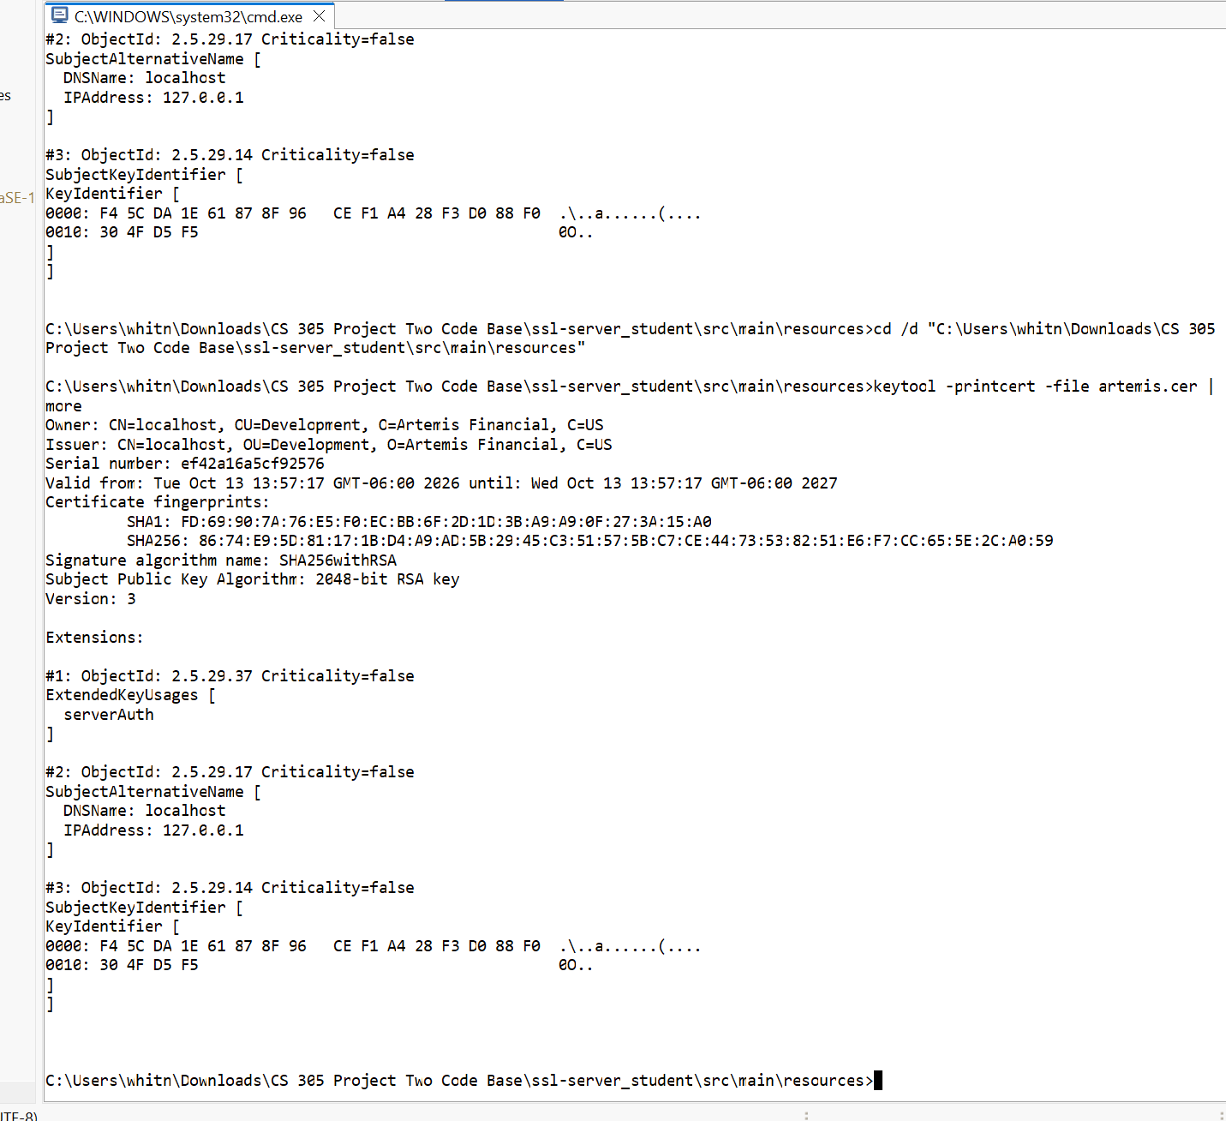

Deploy Cipher
I added a /hash endpoint to SslServerApplication.java that uses Java’s MessageDigest class to calculate a SHA-256 checksum. The input is the unique string “Whitney Dempsey | Artemis Financial | Project Two | 2026”, encoded using UTF-8. The endpoint displays my name, the original data, the algorithm, and the resulting 64-character hexadecimal checksum. I independently calculated the hash of the same string using PowerShell and confirmed that it matched the application’s output. The screenshot below shows the checksum generated by the refactored application.
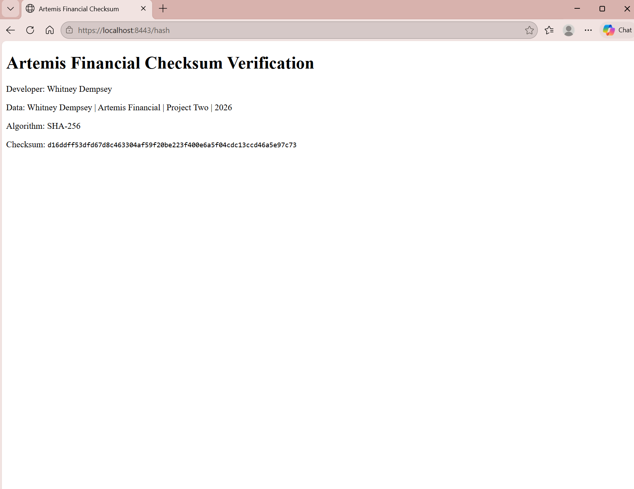

Secure Communications
I configured application.properties to enable HTTPS on port 8443 using the artemis.p12 keystore, the artemis key alias, and the PKCS12 keystore type. The application reads the keystore password from the ARTEMIS_KEYSTORE_PASSWORD environment variable rather than storing it in the source code. After starting the application in Eclipse, I opened https://localhost:8443/hash in Microsoft Edge. The self-signed certificate initially caused a trust warning, so I imported the certificate into my Windows current-user Trusted Root Certification Authorities store for local testing. Edge then displayed the page with a padlock and no certificate warning. The screenshot below demonstrates the working HTTPS connection. A public production deployment would require a certificate issued by a trusted certificate authority rather than relying on this local trust configuration.

Secondary Testing
After refactoring the application, I ran OWASP Dependency-Check Maven version 12.2.2 against the Project Two code base. The scan completed with BUILD SUCCESS and generated an HTML report. It scanned 49 dependencies, including 28 unique dependencies, and reported 14 vulnerable dependencies with 254 vulnerability findings. No findings were suppressed. The NVD analyzer completed, but the Sonatype OSS Index analyzer was disabled because credentials were not configured.

The refactoring added SHA-256 checksum generation and HTTPS configuration without adding or changing third-party application dependencies. The reported findings concern libraries already included in the supplied code base. However, a successful scan does not establish that the application is vulnerability-free, and Dependency-Check does not directly assess the logic of the new Java code. I therefore reviewed the added code manually and tested its behavior separately. The remaining dependency findings require further assessment and remediation before production deployment. The screenshots below show the application running, the completed dependency scan, and the report results.
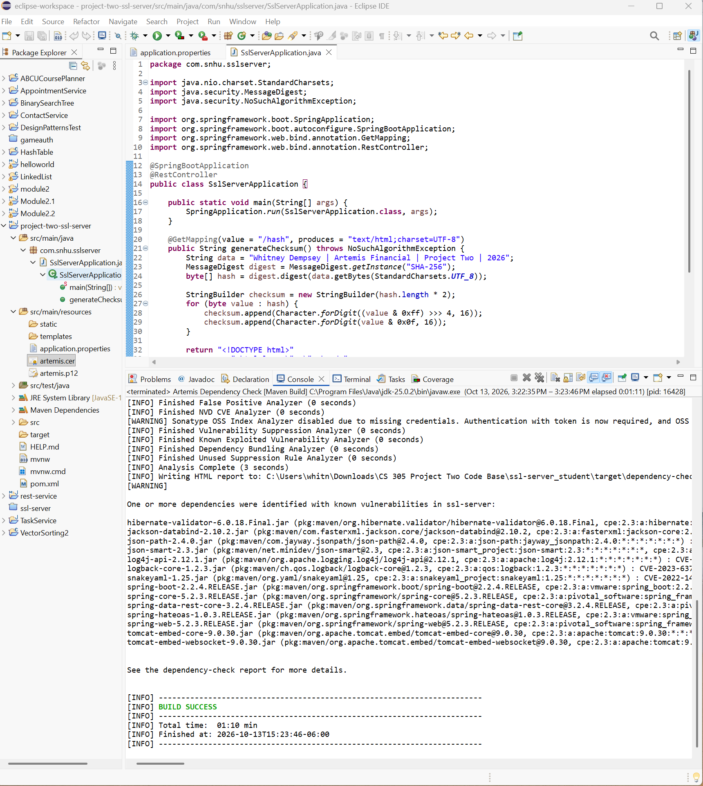

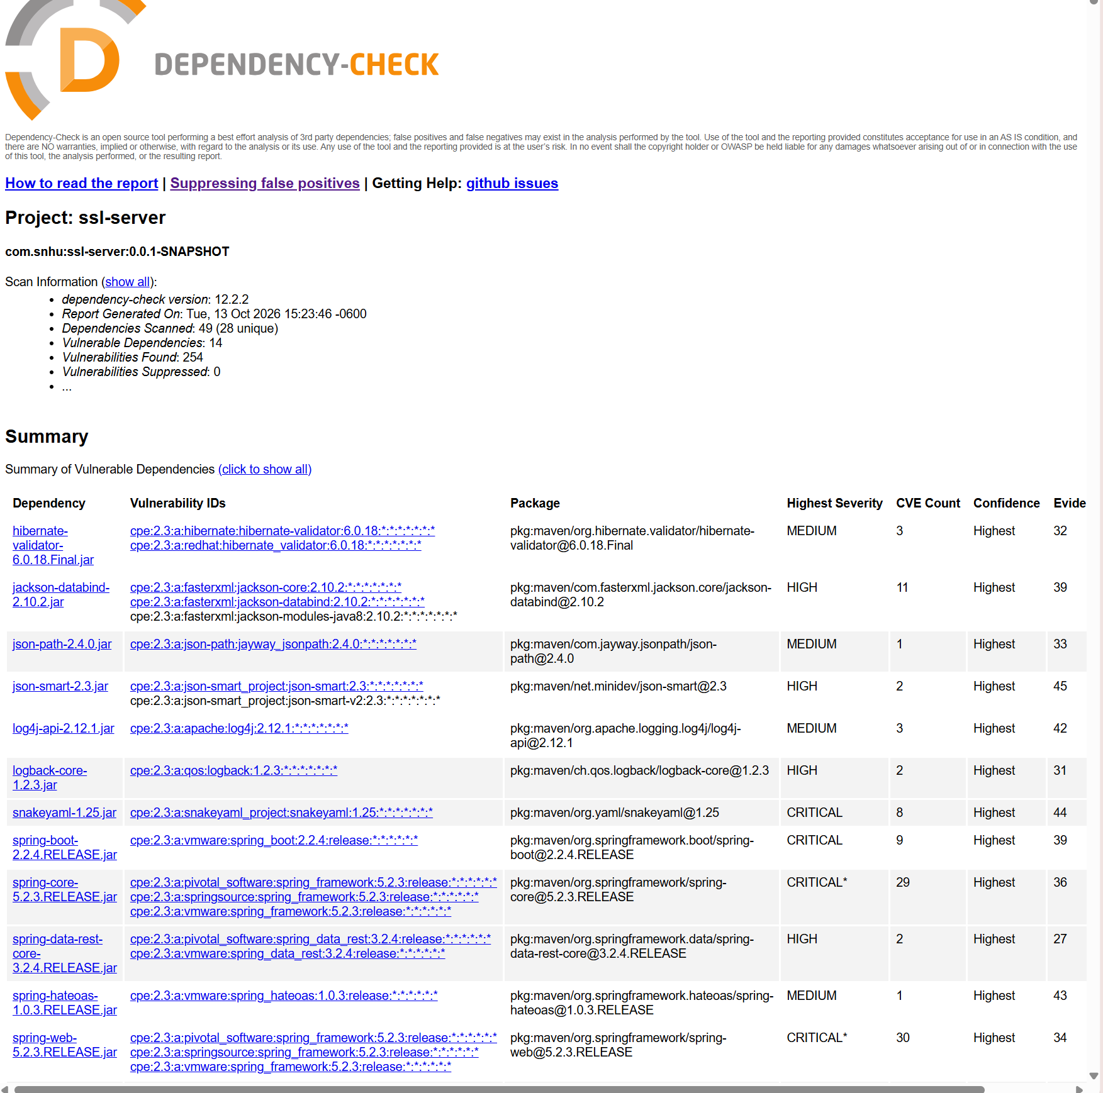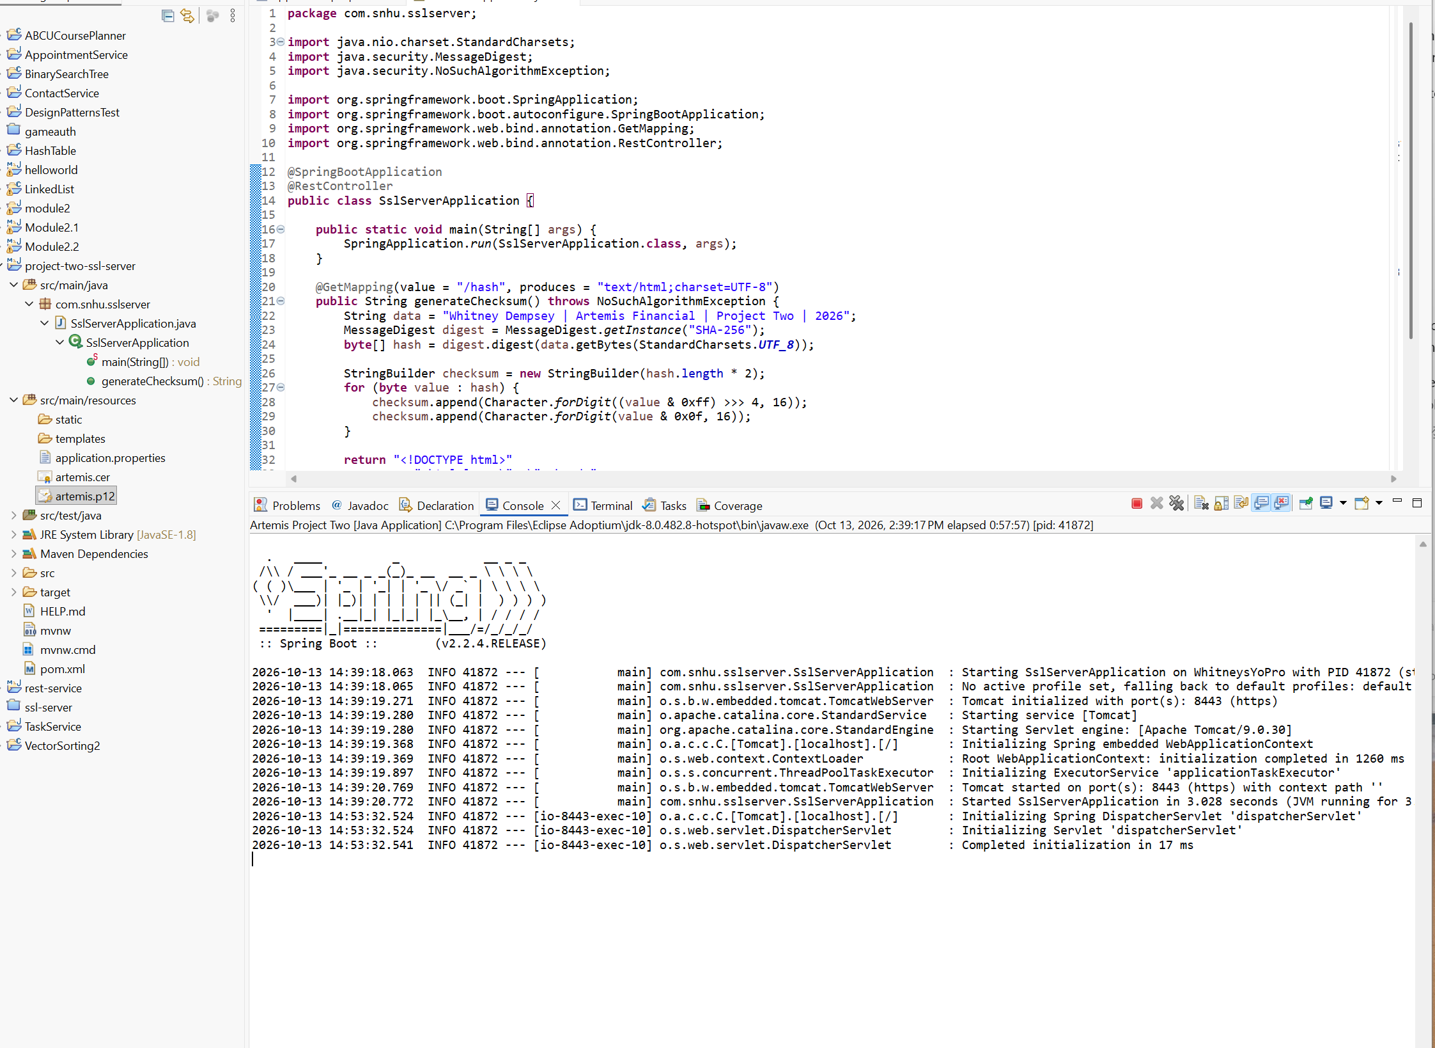

Functional Testing
I manually reviewed SslServerApplication.java and application.properties for syntax, logic, and security issues in the refactored code. The checksum calculation uses UTF-8 encoding and converts each hash byte into two hexadecimal characters, preserving leading zeros. The endpoint processes a fixed demonstration string rather than accepting user input, and the keystore password is read from an environment variable instead of being embedded in the source code.

I ran the application in Eclipse and confirmed that Tomcat started on port 8443 using HTTPS without startup errors. I then opened /hash in Microsoft Edge and verified that the page displayed my name, the unique data string, SHA-256, and the checksum. An independent PowerShell calculation using the same UTF-8 input produced an identical checksum. These checks support the correctness of the demonstrated functionality, but they do not resolve the existing dependency vulnerabilities identified during secondary testing. The screenshots below show the application running and the matching independent checksum calculation.
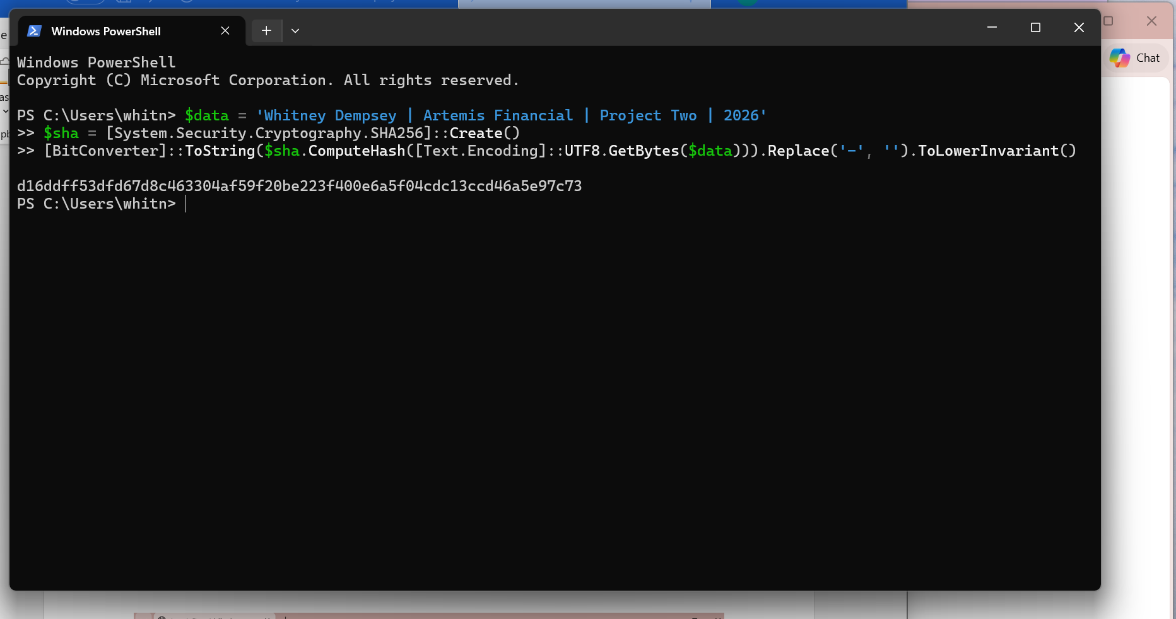

Summary

I refactored Artemis Financial’s application to generate a SHA-256 checksum and serve the result through HTTPS. The changes address the Cryptography, Client/Server, and Code Quality areas of the vulnerability assessment process flow diagram. Cryptography was addressed through checksum generation and certificate configuration, Client/Server security through HTTPS, and Code Quality through manual review and functional testing.

These changes provide complementary layers of protection. HTTPS protects information during transmission, while the checksum allows the demonstration data’s integrity to be checked through an independent calculation. Keeping the keystore password outside the source code also reduces the risk of exposing credentials through shared code. I verified the application’s startup, browser output, and checksum, then reviewed the dependency-check results. The scan identified existing vulnerable libraries that remain a priority for assessment and remediation before production deployment. The demonstrated security improvements do not eliminate the need to maintain and update the application’s dependencies.

Industry Standard Best Practices

I applied secure coding practices by using Java’s established cryptographic functionality instead of developing a custom hashing algorithm. The implementation uses SHA-256, explicit UTF-8 encoding, and consistent hexadecimal conversion. I configured HTTPS with a password-protected keystore and kept its password in an environment variable rather than the source code. The self-signed certificate was used for local testing; a public deployment would require an appropriately trusted certificate. These choices apply the textbook’s discussion of protecting sensitive data and safeguarding cryptographic keys (Manico & Detlefsen, 2014).

To check that the refactoring preserved working behavior, I manually reviewed the changes, ran the application, and independently verified its checksum. I also scanned its dependencies and documented the remaining findings without suppressing them to produce a cleaner report. The unchanged dependency list limits the scope of the changes, but it does not make the existing libraries secure. Before production deployment, Artemis Financial should prioritize applicable high-risk findings, update affected components, and retest.

These practices help protect customer confidentiality, data integrity, and service availability. They also reduce the likelihood of costly incidents, disrupted operations, and damage to customer trust. For a company handling financial information, security must continue through maintenance, vulnerability review, and testing after future changes.

References

Manico, J., & Detlefsen, A. (2014). Iron-clad Java: Building secure web applications. McGraw-Hill
Education.

Oracle. (n.d.). Java security standard algorithm names.
https://docs.oracle.com/javase/9/docs/specs/security/standard-names.html

Southern New Hampshire University. (n.d.). CS 305 vulnerability assessment process flow diagram
[Course handout].

